Race invitation:

4th Annual Season Final @Pyöräkrossiparkki by BMX Helsinki
When? Saturday 1.10.2016
Where? in Pyöräkrossiparkki, Helsinki
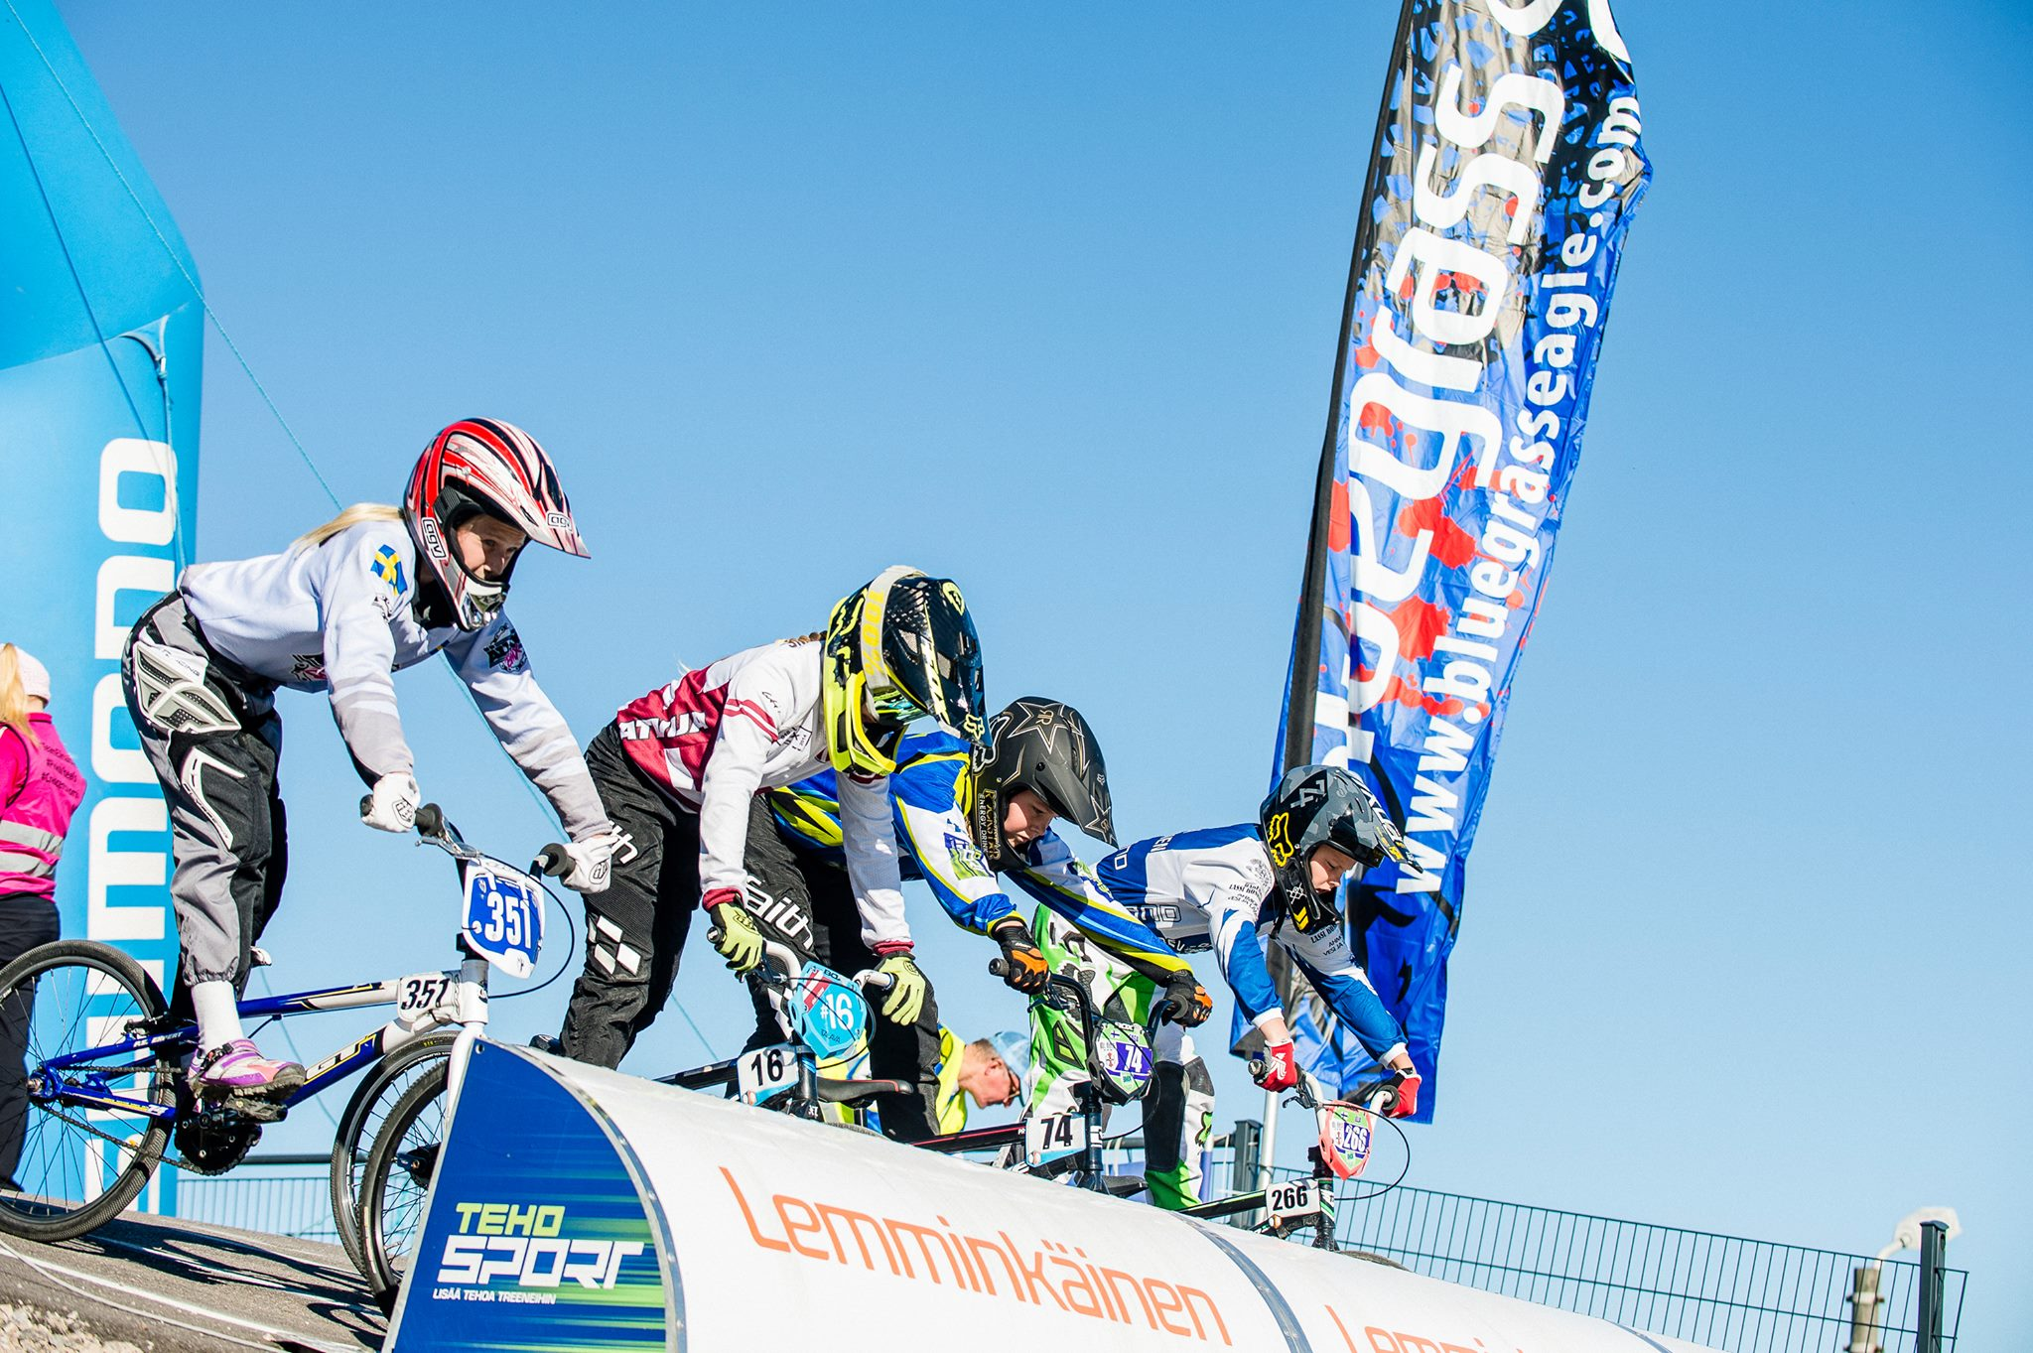
Race Director: Katariina Laakkonen (katariina@pyorakrossiparkki.fi, +358 50 4485437
Secretary: Ville Varis (vilvaris@gmail.com)
Race Office: Veronika Kantanen and Heidi Kjellman

How to enter
Entries by club via email to vilvaris@gmail.com by 28.9. Entry fee 15€ per rider in challenge classes and 25 € per rider in elite classes. Hobby class 0€.
The fee is to be paid to the BMX Helsinki bank account also by 28.9. or in cash (Euros) at the race office.
Late entries have double fee, payable in cash (Euros) in the race office.
Account information: BMX Helsinki, Nordea Bank, IBAN: FI25 1215 3000 1050 18
SWIFT/BIC: NDEAFIHH
Hobby classes have no entry fee. You can sign hobby class -riders at the same time as competition class –riders. Hobby class -riders must have their own insurance.
Registration form: http://tinyurl.com/grgquss

Competition-classes (entry deadline 28.9.2016)
UCI rules, the organizer reserves the right for changes, especially regarding the classes. In Challenge classes no license is needed, but riders must have their own insurance.
In classes with less than 9 participants there will be a 4th moto. This 4th moto is together with the finals.

Elite-classes
Men and Women, 17 years and older. Men elite use Pro-section.
The prize money pool is 1650 euros. The division of the money is in the table below. The organizer reserves the right to change the prize money division according to the number of entries in men’s and women’s classes. The aim is to divide the prize pool according to the number of participants in total. E.g. if 30% of elite class participants are women, they get 30% of the prize money.
If there are 6 or less participants in the elite class, only top 3 get prize money according to the women’s table below. If there are 3 or less participants, only the winner gets prize money.
If there are 3 or less participants in the elite class, the class is combined with challenge classes but awarded separately. In this case the challenge section will be used in the men’s race.
Prize money
Place | Elite Men | Elite Women
1. | 350€ | 350€
2. | 300€ | 100€
3. | 200€ | 50€
4. | 150€
5. | 100€
6. | 50€

Challenge classes
6 and under/ 7-8 / 9-10/ 11-12/ 13-14/ 15-16/ 17 + boys
Cruisers (all ages together, women’s class formed if there are min. 4 entries)
Girls classes are formed according to participants. We try to make all-girl classes. If this is not possible, a girl rider will ride in a class one younger than her age. For example 10 year old girl rides with 7-8 boys class.
No licence is needed for challenge-classes. All participants must have their own insurance and are participating at their own risk!
Good prizes in all classes! All riders 12 and under are given a prize. Others: prizes for 1.,2. and 3. place.

Hobby classes (sign in also in the event office on race day before 12.00)

Novice-class
Girls and boys under 13 who have started BMX in 2015 or 2016, have never raced before or had a license can enter the novice-class. Motos will be formed according to riders’ age and level on the race site. All participants will be given a prize. Normal or lower start hill according to rider’s own choice.

Ladies-class
Open class for girls and women who haven’t raced much or at all. Start from the lower start hill if wanted. Younger girls can also take part in the novice-class . All participants will be given a prize. Bike choice free, 20” or 24”.
Strider-class  Only 3rd and 4th straight of the track. No signing in needed, just show up on time. All participants will be given a prize. | 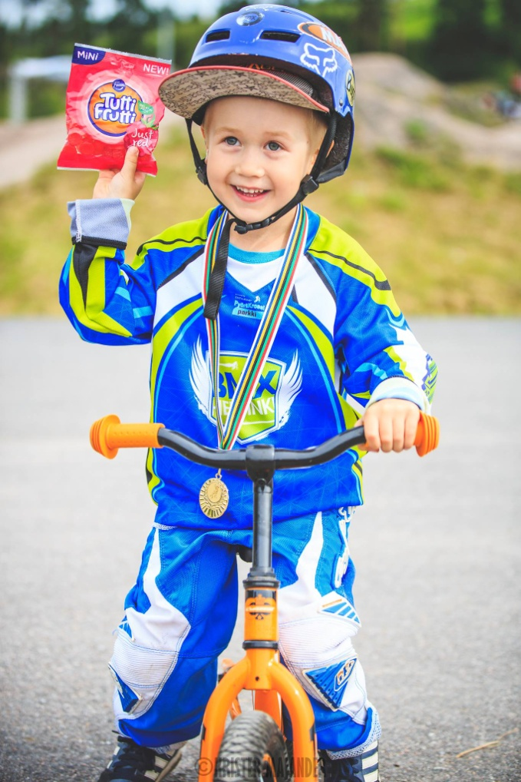

Family relay
Teams of 2 formed by one parent and one child from the same family. 2 laps for the parent, 1 lap for the child.

Program (estimated times)
Friday 30.9.
17.00-19.00 Free training for Season Final riders
Saturday 1.10.
10.00 Race office opens – team registration
12.00-13.00 warm-up for competition classes
- 12-12.25 12 and under and hobby class
- 12.25-12.45 over 12 years
- 12.45.-13.00 pro line
12.30 Team Manager meeting
13.15 Strider competition and prize-giving
13.30 Motos (all challenge, elite and hobby classes)
15 min break between motos and finals
Semifinals
15 min break between semifinals and finals
Finals
Family relay
16:00 (estimate) Prize giving

